Video: Why Docker

Time spent: 30 min

**Technology development**

* Mainframe to PC 90’s
* Baremetal to Virtual 00’s
* Datacenter to Cloud (AWS,Google clound) 10’s
* Host -> Container /Serverless Current

Containers are the Fastest Growing Cloud Enabling Technology

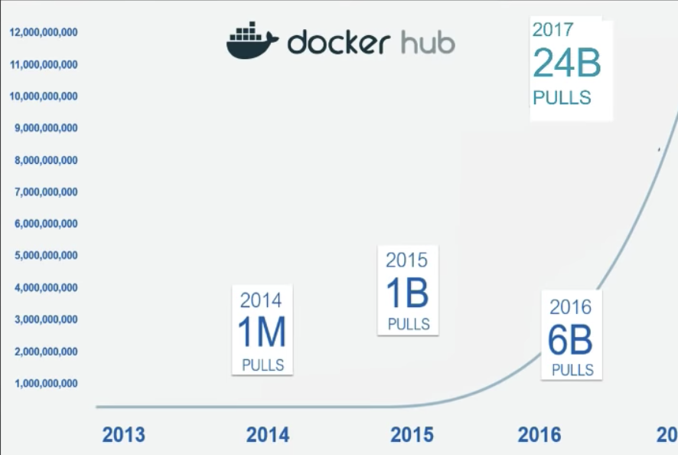

By 2020, more than 50% of global organizations will be running containers in production – Gartner.

**Docker is all about speed**

* Develop Faster
* Build Faster
* Test Faster
* Deploy Faster
* Update Faster
* Recover Faster

**Docker can reduce maintenance and complexity**

80% IT workers are working on managing existed software.

**Real World Companies are using dockers**

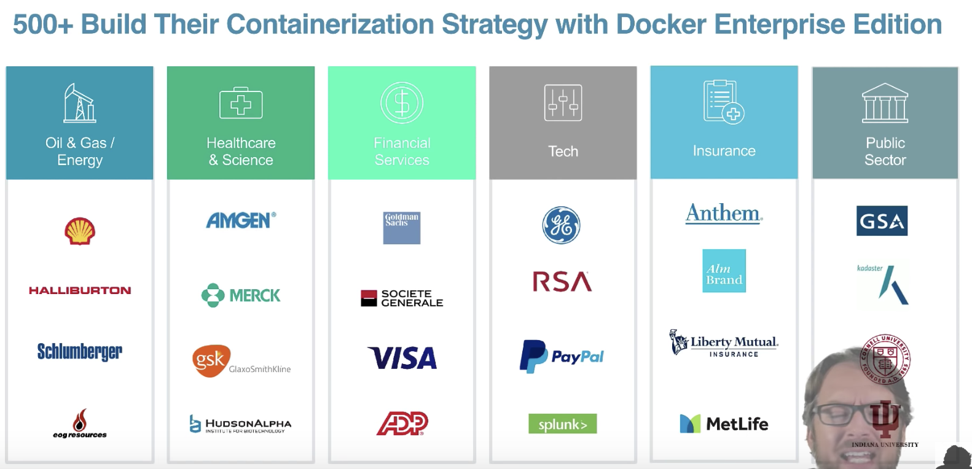

**Summary**

In this video, I have learned the high-level concept and advantages of dockers. There are a lot of real-world big corporation benefit from the docker. In my opinion, it works like the Java virtual machine or a powerful VM.